Experiment 2: Crypt-Arithmetic Problem
Aim
To solve the Crypt-Arithmetic problem using Python.
Objective
To assign digits to letters so that the arithmetic equation is satisfied.
Algorithm
- Take the words in the equation.
- Assign unique digits to each letter.
- Check if the equation is valid.
- Display the solution.
Flowchart
Start
|
v
Read Puzzle
|
v
Assign Digits
|
v
Check Equation
|
Yes/No
|
Display Result
|
Stop
CODE AND OUTPUT
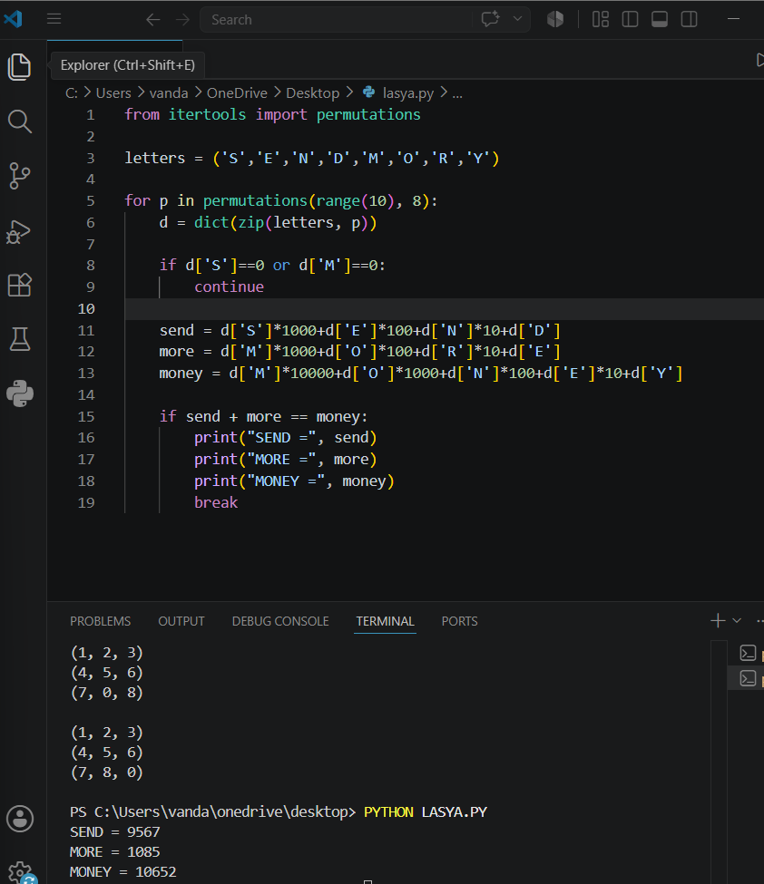
Result
The Crypt-Arithmetic problem was solved successfully.
Conclusion
The program assigns digits to letters and finds the correct arithmetic solution.

